**ALGORITHM**

Set product_price to $100

Get input for name

Get input for quantity

sub_total = product_price * quantity

Set discount_percentage to 0

if quantity >= 100:

discount_percentage = 0.4

elif quantity >= 50:

discount_percentage = 0.3

elif quantity >= 20:

discount_percentage = 0.2

elif quantity >= 10:

discount_percentage = 0.1

discount_amount = sub_total * discount_percentage

total_price = sub_total - discount_amount

Display name

Display quantity

Display discount price

Display sub total

Display discount amount

Display total price

**VARIABLES/CONSTANTS**

product_price (Int)

name (String)

quantity (Int)

sub_total (Double)

discount_percentage (Double)

discount_amount (Double)

total_price (Double)

**FORMULAS**

sub_total = product_price * quantity

discount_amount = sub_total * discount_percentage

total_price = sub_total - discount_amount

**TEST DATA – 5 complete data sets –** Add additional columns as needed:One column for each input, one column for each process (not including decision structures), Only one column for the entire output.

|  |  |  |
| --- | --- | --- |
| **Name** | **Quantity** | **Output (Expected Results)** |
| Clara | 6 | Name: Clara  Quantity of Packages: 6  Discount Percentage: 0.00%  Sub Total: $600.00  Discount Amount: $0.00  Total Price: $600.00 |
| John | 17 | Name: John  Quantity of Packages: 17  Discount Percentage: 0.10%  Sub Total: $1700.00  Discount Amount: $170.00  Total Price: $1530.00 |
| Michael | 22 | Name: Michael  Quantity of Packages: 22  Discount Percentage: 0.20%  Sub Total: $2200.00  Discount Amount: $440.00  Total Price: $1760.00 |
| Talia | 70 | Name: Talia  Quantity of Packages: 70  Discount Percentage: 0.30%  Sub Total: $7000.00  Discount Amount: $2100.00  Total Price: $4900.00 |
| Selina | 245 | Name: Selina  Quantity of Packages: 245  Discount Percentage: 0.40%  Sub Total: $24500.00  Discount Amount: $9800.00  Total Price: $14700.00 |

**FLOWCHART**

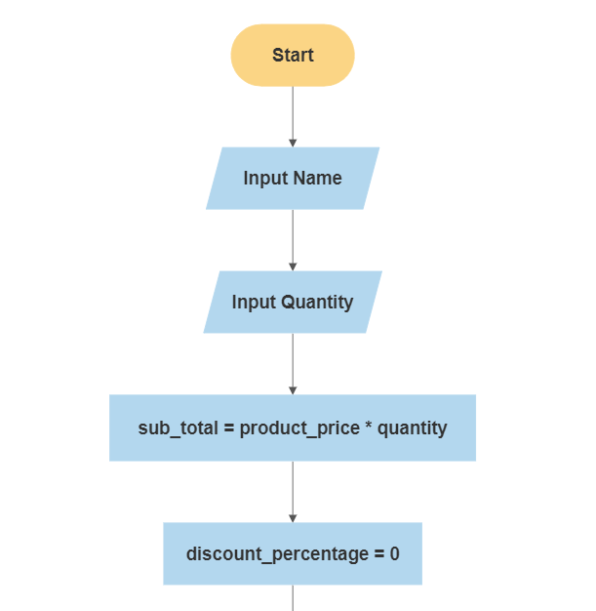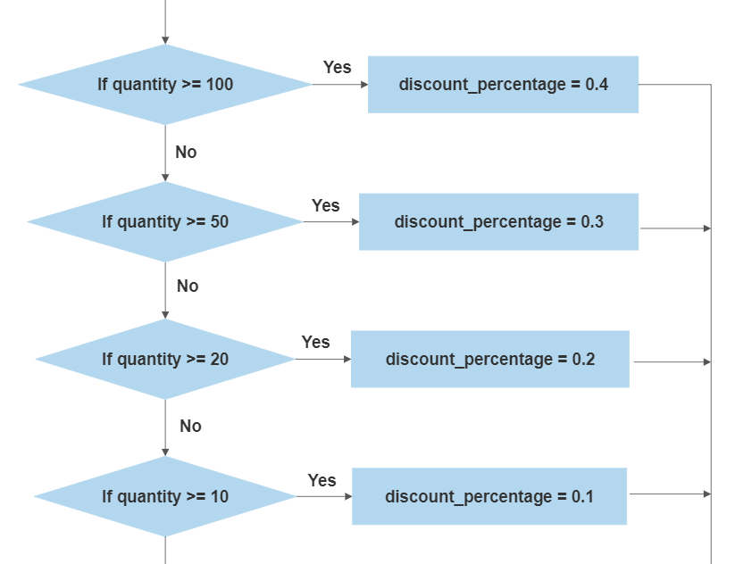

A

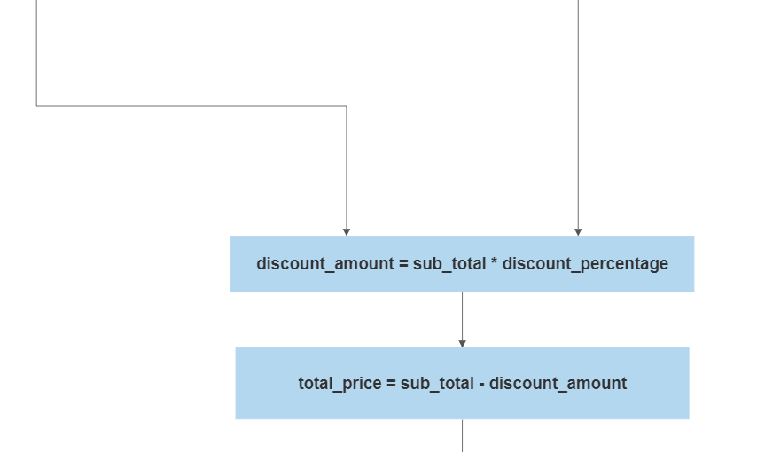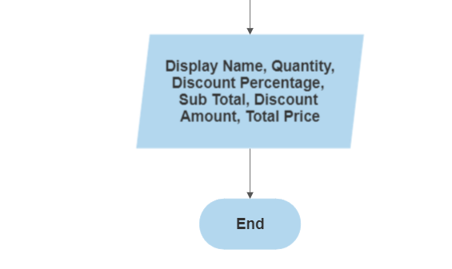

A

**PYTHON CODE**

product_price = 100

print("\n-------------------------------")

print(" SOFTWARE SALES")

print("-------------------------------\n")

name = input("Enter your name : ")

quantity = int(input("Enter number of packages : "))

sub_total = product_price * quantity

discount_percentage = 0

if quantity >= 100:

discount_percentage = 0.4

elif quantity >= 50:

discount_percentage = 0.3

elif quantity >= 20:

discount_percentage = 0.2

elif quantity >= 10:

discount_percentage = 0.1

discount_amount = sub_total * discount_percentage

total_price = sub_total - discount_amount

print(f"\nName: {name}")

print(f"Quantity of Packages: {quantity}")

print("Discount Percentage: {:.2f}%".format(discount_percentage))

print("Sub Total: ${:.2f}".format(sub_total))

print("Discount Amount: ${:.2f}".format(discount_amount))

print("Total Price: ${:.2f}".format(total_price))

print("\n-------------------------------")

print(" THANK YOU")

print("-------------------------------")

**TEST DATA EXECUTION RESULTS**

